What is Cloud Computing

The term cloud refers to a network or the internet. **It is a technology that uses remote servers (In Data Centers across the globe) on the internet to store, manage, and access data online rather than local drives.** The data can be anything such as files, images, documents, audio, video, and more.

There are the following operations that we can do using cloud computing: 5M

* Developing new applications and services
* Storage, back up, and recovery of data
* Hosting blogs and websites
* Delivery of software on demand
* Analysis of data
* Streaming videos and audios

Why Cloud Computing?

Small as well as large IT companies, follow the traditional methods to provide the IT infrastructure. That means **for any IT company, we need a Server Room that is the basic need of IT companies**.

In that server room, there should be a **database server, mail server, networking, firewalls, routers, modem, switches**, QPS (Query Per Second means how much queries or load will be handled by the server), configurable system, high net speed, and the maintenance engineers.

**To establish such IT infrastructure, we need to spend lots of money. To overcome all these problems and to reduce the IT infrastructure cost, Cloud Computing comes into existence.**

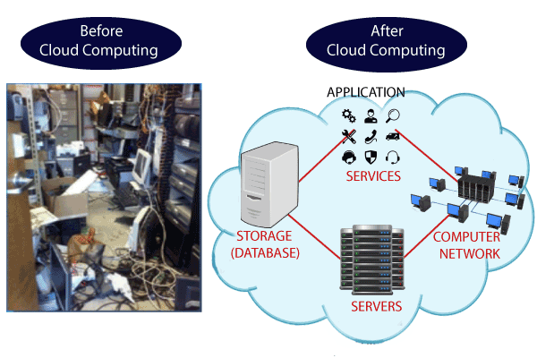

Characteristics of Cloud Computing

The characteristics of cloud computing are given below:

**1) Agility**

The cloud **works in a distributed computing environment**. It shares resources among users and works very fast.

**2) High availability and reliability**

The availability of servers is high and more reliable because the **chances of infrastructure failure are minimum**.

**3) High Scalability**

Cloud offers **"on-demand" provisioning of resources on a large scale**, without having engineers for peak loads.

**4) Multi-Sharing**

With the help of cloud computing, **multiple users and applications can work more efficiently** with cost reductions by sharing common infrastructure.

**5) Device and Location Independence**

Cloud computing enables the users to access systems using a web browser regardless of their location or what device they use e.g. PC, mobile phone, etc. **As infrastructure is off-site** (typically provided by a third-party) **and accessed via the Internet, users can connect from anywhere**.

**6) Maintenance**

Maintenance of cloud computing applications is easier, since they **do not need to be installed on each user's computer and can be accessed from different places**. So, it reduces the cost also.

**7) Low Cost**

By using cloud computing, the cost will be reduced because to take the services of cloud computing, **IT company need not to set its own infrastructure** and **pay-as-per usage of resources.**

**8) Services in the pay-per-use mode**

Application Programming Interfaces**(APIs) are provided to the users so that they can access services on the cloud** by using these APIs **and pay the charges as per the usage of services**.

# **Advantages and Disadvantages of Cloud Computing**

## Advantages of Cloud Computing

As we all know that Cloud computing is trending technology. Almost every company switched their services on the cloud to rise the company growth.

Here, we are going to discuss some important advantages of Cloud Computing-

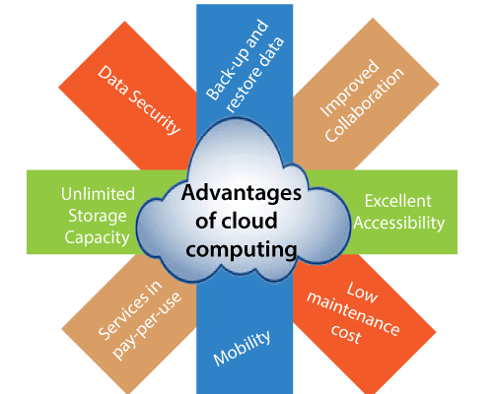

### **1) Back-up and restore data**

Once the data is stored in the cloud, it is easier to get back-up and restore that data using the cloud.

### **2) Improved collaboration**

Cloud applications improve collaboration by allowing groups of people to quickly and easily share information in the cloud via shared storage.

Trump Announces Launch of His Own Social Media Site

### **3) Excellent accessibility**

Cloud allows us to quickly and easily access store information anywhere, anytime in the whole world, using an internet connection. An internet cloud infrastructure increases organization productivity and efficiency by ensuring that our data is always accessible.

### **4) Low maintenance cost**

Cloud computing reduces both hardware and software maintenance costs for organizations.

### **5) Mobility**

Cloud computing allows us to easily access all cloud data via mobile.

### **6) IServices in the pay-per-use model**

Cloud computing offers Application Programming Interfaces (APIs) to the users for access services on the cloud and pays the charges as per the usage of service.

### **7) Unlimited storage capacity**

Cloud offers us a huge amount of storing capacity for storing our important data such as documents, images, audio, video, etc. in one place.

### **8) Data security**

Data security is one of the biggest advantages of cloud computing. Cloud offers many advanced features related to security and ensures that data is securely stored and handled.

## Disadvantages of Cloud Computing

A list of the disadvantage of cloud computing is given below -

### **1) Internet Connectivity**

As you know, in cloud computing, every data (image, audio, video, etc.) is stored on the cloud, and we access these data through the cloud by using the internet connection. If you do not have good internet connectivity, you cannot access these data. However, we have no any other way to access data from the cloud.

### **2) Vendor lock-in**

Vendor lock-in is the biggest disadvantage of cloud computing. Organizations may face problems when transferring their services from one vendor to another. As different vendors provide different platforms, that can cause difficulty moving from one cloud to another.

### **3) Limited Control**

As we know, cloud infrastructure is completely owned, managed, and monitored by the service provider, so the cloud users have less control over the function and execution of services within a cloud infrastructure.

### **4) Security**

Although cloud service providers implement the best security standards to store important information. But, before adopting cloud technology, you should be aware that you will be sending all your organization's sensitive information to a third party, i.e., a cloud computing service provider. While sending the data on the cloud, there may be a chance that your organization's information is hacked by Hackers.

# **Cloud Computing Architecture**

As we know, cloud computing technology is used by both small and large organizations to **store the information** in cloud and **access** it from anywhere at anytime using the internet connection.

Cloud computing architecture is a combination of **service-oriented architecture** and **event-driven architecture**.

Cloud computing architecture is divided into the following two parts -

* Front End
* Back End

The below diagram shows the architecture of cloud computing -

Prime Ministers of India | List of Prime Minister of India (1947-2020)

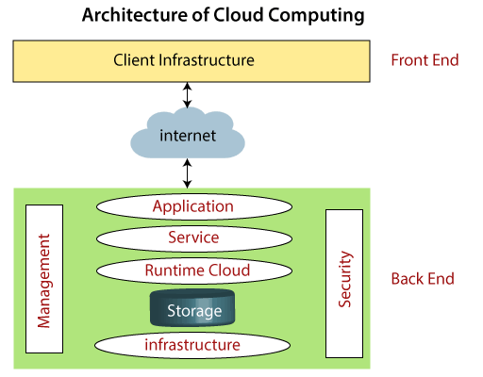

### **Front End**

The front end is used by the client. It contains client-side interfaces and applications that are required to access the cloud computing platforms. The front end includes web servers (including Chrome, Firefox, internet explorer, etc.), thin & fat clients, tablets, and mobile devices.

### **Back End**

The back end is used by the service provider. It manages all the resources that are required to provide cloud computing services. It includes a huge amount of data storage, security mechanism, virtual machines, deploying models, servers, traffic control mechanisms, etc.

#### **Note: Both front end and back end are connected to others through a network, generally using the internet connection.**

## Components of Cloud Computing Architecture

There are the following components of cloud computing architecture -

**1. Client Infrastructure**

Client Infrastructure is a Front end component. It provides **GUI** (Graphical User Interface) to **interact with the cloud.**

**2. Application**

The application may be any **software or platform** that a client wants to access.

**3. Service**

A Cloud Services manages that which type of service you access according to the client’s requirement.

Cloud computing offers the following three type of services:

**i. Software as a Service (SaaS) –**It is also known as **cloud application services**. Mostly, SaaS applications run directly through the web browser means we do not require to download and install these applications. Some important example of SaaS is given below –

**Example:** Google Apps, Salesforce Dropbox, Slack, Hubspot, Cisco WebEx.

**ii. Platform as a Service (PaaS) –** It is also known as **cloud platform** **services**. It is quite similar to SaaS, but the difference is that PaaS provides a platform for software creation, but using SaaS, we can access software over the internet without the need of any platform.

**Example:** Windows Azure, Force.com, Magento Commerce Cloud, OpenShift.

**iii. Infrastructure as a Service (IaaS) –**It is also known as **cloud infrastructure services**. It is responsible for managing applications data, middleware, and runtime environments.

**Example:** Amazon Web Services (AWS) EC2, Google Compute Engine (GCE), Cisco Metapod, Microsoft Azure.

**4. Runtime Cloud**

Runtime Cloud provides the **execution and runtime environment** to the virtual machines.

**5. Storage**

Storage is one of the most important components of cloud computing. It provides a huge amount of storage capacity in the cloud to store and manage data.

**6. Infrastructure**

It provides services on the **host level**, **application level**, and **network level**. Cloud infrastructure includes hardware and software components such as servers, storage, network devices, **virtualization software**, and other storage resources that are needed to support the cloud computing model.

**7. Management**

Management is used to manage components such as application, service, runtime cloud, storage, infrastructure, and other security issues in the backend and establish coordination between them.

**8. Security**

Security is an in-built back end component of cloud computing. It implements a security mechanism in the back end.

**9. Internet**

The Internet is medium through which front end and back end can interact and communicate with each other.

# **Cloud Computing Applications**

Cloud service providers provide various applications in the field of art, business, data storage and backup services, education, entertainment, management, social networking, etc.

The most widely used cloud computing applications are given below -

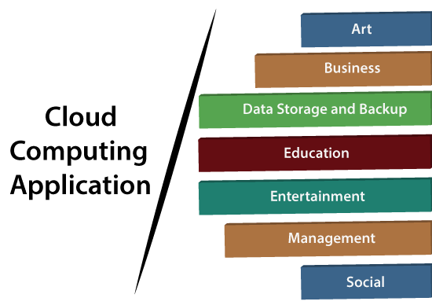

## 1. Art Applications

Cloud computing offers various art applications for quickly and easily design **attractive cards, booklets,** and **images**. Some most commonly used cloud art applications are given below:

**i Moo**

Moo is one of the best cloud art applications. It is used for designing and printing business cards, postcards, and mini cards.

**ii. Vistaprint**

Vistaprint allows us to easily design various printed marketing products such as business cards, Postcards, Booklets, and wedding invitations cards.

**iii. Adobe Creative Cloud**

Adobe creative cloud is made for designers, artists, filmmakers, and other creative professionals. It is a suite of apps which includes PhotoShop image editing programming, Illustrator, InDesign, TypeKit, Dreamweaver, XD, and Audition.

## 2. Business Applications

Business applications are based on cloud service providers. Today, every organization requires the cloud business application to grow their business. It also ensures that business applications are 24*7 available to users.

There are the following business applications of cloud computing -

**i. MailChimp**

MailChimp is an **email publishing platform** which provides various options to **design, send,** and **save** templates for emails.

**ii. Salesforce**

Salesforce platform provides tools for sales, service, marketing, e-commerce, and more. It also provides a cloud development platform.

**iii. Chatter**

Chatter helps us to **share important information** about the organization in real time.

**iv. Paypal**

Paypal offers the simplest and easiest **online payment** mode using a secure internet account. Paypal accepts the payment through debit cards, credit cards, and also from Paypal account holders.

## 3. Data Storage and Backup Applications

Cloud computing allows us to store information (data, files, images, audios, and videos) on the cloud and access this information using an internet connection. As the cloud provider is responsible for providing security, so they offer various backup recovery application for retrieving the lost data.

A list of data storage and backup applications in the cloud are given below -

**i. Box.com**

Box provides an online environment for **secure content management, workflow,** and **collaboration**. It allows us to store different files such as Excel, Word, PDF, and images on the cloud. The main advantage of using box is that it provides drag & drop service for files and easily integrates with Office 365, G Suite, Salesforce, and more than 1400 tools.

**ii. Google G Suite**

Google G Suite is one of the best **cloud storage** and **backup** application. It includes Google Calendar, Docs, Forms, Google+, Hangouts, as well as cloud storage and tools for managing cloud apps. The most popular app in the Google G Suite is Gmail. Gmail offers free email services to users.

## 4. Education Applications

Cloud computing in the education sector becomes very popular. It offers various **online distance learning platforms** and **student information portals** to the students. The advantage of using cloud in the field of education is that it offers strong virtual classroom environments, Ease of accessibility, secure data storage, scalability, greater reach for the students, and minimal hardware requirements for the applications.

There are the following education applications offered by the cloud -

**i. Google Apps for Education**

Google Apps for Education is the most widely used platform for free web-based email, calendar, documents, and collaborative study.

**ii. Chromebooks for Education**

Chromebook for Education is one of the most important Google's projects. It is designed for the purpose that it enhances education innovation.

**iii. Tablets with Google Play for Education**

It allows educators to quickly implement the latest technology solutions into the classroom and make it available to their students.

**iv. AWS in Education**

AWS cloud provides an education-friendly environment to universities, community colleges, and schools.

### **5. Entertainment Applications**

Entertainment industries use a **multi-cloud strategy** to interact with the target audience. Cloud computing offers various entertainment applications such as online games and video conferencing.

**i. Online games**

Today, cloud gaming becomes one of the most important entertainment media. It offers various online games that run remotely from the cloud. The best cloud gaming services are Shaow, GeForce Now, Vortex, Project xCloud, and PlayStation Now.

**ii. Video Conferencing Apps**

Video conferencing apps provides a simple and instant connected experience. It allows us to communicate with our business partners, friends, and relatives using a cloud-based video conferencing. The benefits of using video conferencing are that it reduces cost, increases efficiency, and removes interoperability.

## 6. Management Applications

Cloud computing offers various cloud management tools which help admins to manage all types of cloud activities, such as resource deployment, data integration, and disaster recovery. These management tools also provide administrative control over the platforms, applications, and infrastructure.

Some important management applications are -

## i. Toggl

Toggl helps users to track allocated time period for a particular project.

## ii. Evernote

Evernote allows you to sync and save your recorded notes, typed notes, and other notes in one convenient place. It is available for both free as well as a paid version.

It uses platforms like Windows, macOS, Android, iOS, Browser, and Unix.

## iii. Outright

Outright is used by management users for the purpose of accounts. It helps to track income, expenses, profits, and losses in real-time environment.

## iv. GoToMeeting

GoToMeeting provides **Video Conferencing** and **online meeting apps**, which allows you to start a meeting with your business partners from anytime, anywhere using mobile phones or tablets. Using GoToMeeting app, you can perform the tasks related to the management such as join meetings in seconds, view presentations on the shared screen, get alerts for upcoming meetings, etc.

## 7. Social Applications

Social cloud applications allow a large number of users to connect with each other using social networking applications such as **Facebook, Twitter, Linkedln,** etc.

There are the following cloud based social applications -

**i. Facebook**

Facebook is a **social networking website** which allows active users to share files, photos, videos, status, more to their friends, relatives, and business partners using the cloud storage system. On Facebook, we will always get notifications when our friends like and comment on the posts.

**ii. Twitter**

Twitter is a **social networking** site. It is a **microblogging** system. It allows users to follow high profile celebrities, friends, relatives, and receive news. It sends and receives short posts called tweets.

**iii. Yammer**

Yammer is the **best team collaboration** tool that allows a team of employees to chat, share images, documents, and videos.

**iv. LinkedIn**

LinkedIn is a **social network** for students, freshers, and professionals.

# **What are the Security Risks of Cloud Computing**

Cloud computing provides various advantages, such as improved collaboration, excellent accessibility, Mobility, Storage capacity, etc. But there are also security risks in cloud computing.

Some most common Security Risks of Cloud Computing are given below-

### **Data Loss**

Data loss is the most common cloud security risks of cloud computing. It is also known as data leakage. Data loss is the process in which data is being deleted, corrupted, and unreadable by a user, software, or application. In a cloud computing environment, data loss occurs when our sensitive data is somebody else's hands, one or more data elements can not be utilized by the data owner, hard disk is not working properly, and software is not updated.

### **Hacked Interfaces and Insecure APIs**

As we all know, cloud computing is completely depends on Internet, so it is compulsory to protect interfaces and APIs that are used by external users. APIs are the easiest way to communicate with most of the cloud services. In cloud computing, few services are available in the public domain. These services can be accessed by third parties, so there may be a chance that these services easily harmed and hacked by hackers.

Keep Watching

### **Data Breach**

Data Breach is the process in which the confidential data is viewed, accessed, or stolen by the third party without any authorization, so organization's data is hacked by the hackers.

### **Vendor lock-in**

Vendor lock-in is the of the biggest security risks in cloud computing. Organizations may face problems when transferring their services from one vendor to another. As different vendors provide different platforms, that can cause difficulty moving one cloud to another.

### **Increased complexity strains IT staff**

Migrating, integrating, and operating the cloud services is complex for the IT staff. IT staff must require the extra capability and skills to manage, integrate, and maintain the data to the cloud.

### **Spectre & Meltdown(Hacking)**

Spectre & Meltdown allows programs to view and steal data which is currently processed on computer. It can run on personal computers, mobile devices, and in the cloud. It can store the password, your personal information such as images, emails, and business documents in the memory of other running programs.

### **Denial of Service (DoS) attacks**

Denial of service (DoS) attacks occur when the system receives too much traffic to buffer the server. Mostly, DoS attackers target web servers of large organizations such as banking sectors, media companies, and government organizations. To recover the lost data, DoS attackers charge a great deal of time and money to handle the data.

### **Account hijacking**

Account hijacking is a serious security risk in cloud computing. It is the process in which individual user's or organization's cloud account (bank account, e-mail account, and social media account) is stolen by hackers. The hackers use the stolen account to perform unauthorized activities.

# **Types of Cloud**

There are the following 4 types of cloud that you can deploy according to the organization's needs-

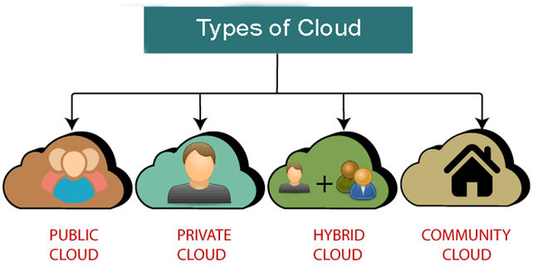

## Public Cloud

Public cloud is **open to all** to store and access information via the Internet using the pay-per-usage method.

In public cloud, computing resources are managed and operated by the Cloud Service Provider (CSP).

**Example:** Amazon elastic compute cloud (EC2), IBM SmartCloud Enterprise, Microsoft, Google App Engine, Windows Azure Services Platform.

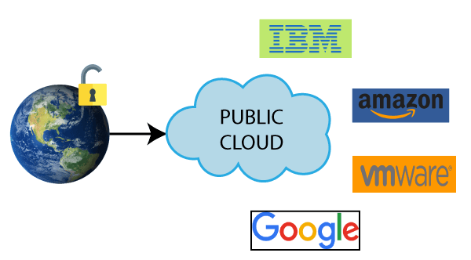

### **Advantages of Public Cloud**

There are the following advantages of Public Cloud -

* Public cloud is owned at a **lower cost** than the private and hybrid cloud.
* Public cloud is maintained by the cloud service provider, so do **not need to worry about the maintenance.**
* Public cloud is easier to integrate. Hence it offers a better **flexibility** approach to consumers.
* Public cloud is **location independent** because its services are delivered through the internet.
* Public cloud is **highly scalable** as per the requirement of computing resources.
* It is **accessible by the general public**, so there is no limit to the number of users.

### **Disadvantages of Public Cloud**

* Public Cloud is **less secure** because resources are shared publicly.
* Performance **depends upon the high-speed internet network link to the cloud provider.**
* The Client has **no control of data**

.

## Private Cloud

Private cloud is also known as an **internal cloud** or **corporate cloud**. It is used by organizations to build and manage their own data centers internally or by the third party. It can be deployed using Opensource tools such as Openstack and Eucalyptus.

Based on the location and management, **National Institute of Standards and Technology** (NIST) divide private cloud into the following two parts-

* On-premise private cloud
* Outsourced private cloud

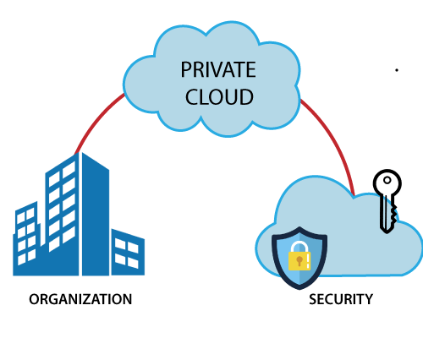

### **Advantages of Private Cloud**

There are the following advantages of the Private Cloud -

* Private cloud provides a **high level of security and privacy** to the users.
* Private cloud offers better **performance** with improved speed and space capacity.
* It allows the IT team to quickly **allocate and deliver on-demand IT resources**.
* The **organization has full control over the cloud because it is managed by the organization itself**. So, there is no need for the organization to depends on anybody.
* It is suitable for organizations that require a separate cloud for their personal use and data security is the first priority.

### **Disadvantages of Private Cloud**

* **Skilled people** are required to manage and operate cloud services.
* **Private cloud is accessible within the organization**, so the area of operations is limited.
* Private cloud is **not suitable for organizations that have a high user base**, and organizations that do not have the prebuilt infrastructure, sufficient manpower to maintain and manage the cloud.

**Hybrid Cloud**

Hybrid Cloud is a combination of the public cloud and the private cloud. we can say:

**Hybrid Cloud = Public Cloud + Private Cloud**

Hybrid cloud is partially secure because the services which are running on the public cloud can be accessed by anyone, while the services which are running on a private cloud can be accessed only by the organization's users.

**Example: Google Application Suite (Gmail, Google Apps, and Google Drive), Office 365 (MS Office on the Web and One Drive), Amazon Web Services.**

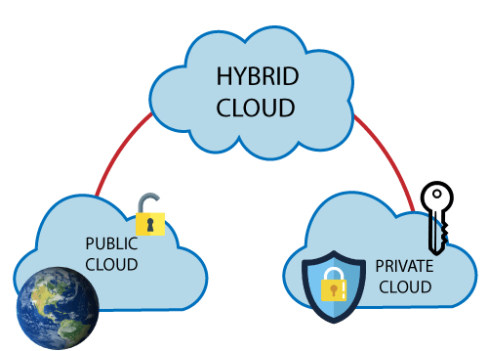

### **Advantages of Hybrid Cloud**

There are the following advantages of Hybrid Cloud -

* Hybrid cloud is suitable for organizations that require **more security than the public cloud.**
* Hybrid cloud helps you to **deliver new products and services more quickly.**
* Hybrid cloud provides an excellent way to **reduce the risk**.
* Hybrid cloud offers **flexible resources** because of the public cloud and secure resources because of the private cloud.

### **Disadvantages of Hybrid Cloud**

* In Hybrid Cloud, **security feature** is not as good as the private cloud.
* Managing a hybrid cloud is **complex** because it is difficult to manage more than one type of deployment model.
* In the hybrid cloud, the **reliability of the services depends on cloud service providers.**

## Community Cloud

Community cloud **allows systems and services to be accessible by a group of several organizations to share the information between the organization and a specific community**. It is owned, managed, and operated by one or more organizations in the community, a third party, or a combination of them.

**Example:** Health Care community cloud

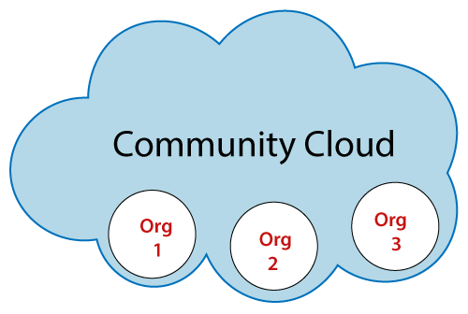

### **Advantages of Community Cloud**

There are the following advantages of Community Cloud -

* Community cloud is **cost-effective** because the whole cloud is being shared by several organizations or communities.
* Community cloud is suitable for organizations that want to have a **collaborative** cloud with more security features than the public cloud.
* It provides **better security than the public cloud.**
* It provides **collaborative and distributive environment.**
* Community cloud allows us to **share cloud resources, infrastructure, and other capabilities** among various organizations.

### **Disadvantages of Community Cloud**

* Community cloud is **not a good choice for every organization.**
* **Security features are not as good as the private cloud.**
* It is **not suitable if there is no collaboration.**
* The **fixed amount of data storage and bandwidth is shared among all community members.**

# **Cloud Service Models**

There are the following three types of cloud service models -

1. [Infrastructure as a Service (IaaS)](https://www.javatpoint.com/cloud-service-models#IaaS)
2. [Platform as a Service (PaaS)](https://www.javatpoint.com/cloud-service-models#PaaS)
3. [Software as a Service (SaaS)](https://www.javatpoint.com/cloud-service-models#SaaS)

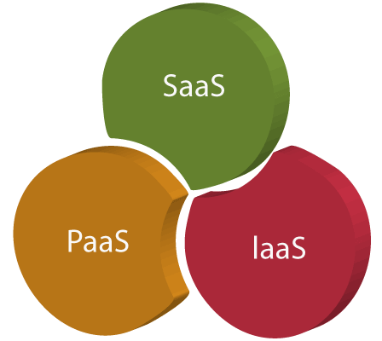

# **Infrastructure as a Service | IaaS**

Iaas is also known as **Hardware as a Service (HaaS)**. It is one of the layers of the cloud computing platform. It allows customers to outsource their IT infrastructures such as **servers, networking, processing, storage, virtual machines**, and other resources. Customers access these resources on the Internet using a **pay-as-per use model.**

IaaS cloud computing platform layer eliminates the need for every organization to maintain the IT infrastructure.

IaaS provider provides the following services -

1. **Compute:** Computing as a Service includes virtual central processing units and virtual main memory for the Vms that is provisioned to the end- users.
2. **Storage:** IaaS provider provides back-end storage for storing files.
3. **Network:** Network as a Service (NaaS) provides networking components such as routers, switches, and bridges for the Vms.
4. **Load balancers:** It provides load balancing capability at the infrastructure layer.

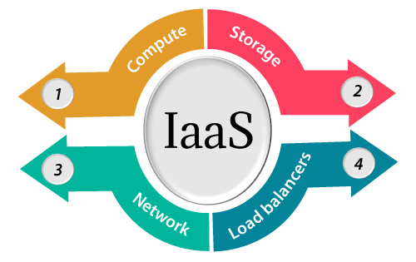

## Advantages of IaaS cloud computing layer

There are the following advantages of IaaS computing layer -

**1. Shared infrastructure**

IaaS allows multiple users to share the same physical infrastructure.

**2. Web access to the resources**

Iaas allows IT users to access resources over the internet.

**3. Pay-as-per-use model**

IaaS providers provide services based on the pay-as-per-use basis. The users are required to pay for what they have used.

**4. Focus on the core business**

IaaS providers focus on the organization's core business rather than on IT infrastructure.

**5. On-demand scalability**

On-demand scalability is one of the biggest advantages of IaaS. Using IaaS, users do not worry about to upgrade software and troubleshoot the issues related to hardware components.

## Disadvantages of IaaS cloud computing layer

**1. Security**

Security is one of the biggest issues in IaaS. Most of the IaaS providers are not able to provide 100% security.

**2. Maintenance & Upgrade**

Although IaaS service providers maintain the software, but they do not upgrade the software for some organizations.

**3. Interoperability issues**

It is difficult to migrate VM from one IaaS provider to the other, so the customers might face problem related to vendor lock-in.

## Top Iaas Providers who are providing IaaS cloud computing platform

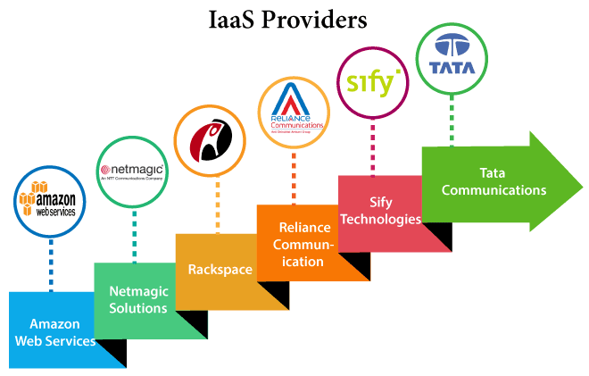

# **Platform as a Service | PaaS**

Platform as a Service (PaaS) **provides a runtime environment**. **It allows programmers to easily create, test, run, and deploy web applications.** You can purchase these applications from a cloud service provider on a pay-as-per use basis and access them using the Internet connection. In PaaS, back end scalability is managed by the cloud service provider, so end- users do not need to worry about managing the infrastructure.

PaaS includes infrastructure (web **servers, storage, and networking**) and platform (middleware, development tools, database management systems, business intelligence, and more) to support the web application life cycle.

**Example:** Google App Engine, Force.com, Joyent, Azure.

PaaS providers provide the Programming languages, Application frameworks, Databases, and Other tools:

Features of Java

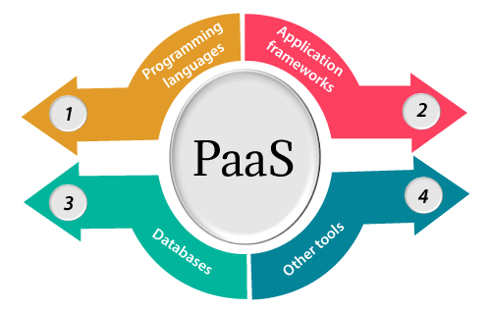

### **1. Programming languages**

PaaS providers provide various **programming languages for the developers to develop the applications.** Some popular programming languages provided by PaaS providers are Java, PHP, Ruby, Perl, and Go.

### **2. Application frameworks**

PaaS providers provide **application frameworks** to easily understand the application development. Some popular application frameworks provided by PaaS providers are **Node.js, Drupal, Joomla, WordPress, Spring, Play, Rack, and Zend.**

### **3. Databases**

PaaS providers provide various databases such as **ClearDB, PostgreSQL, MongoDB, and Redis** to communicate with the applications.

### **4. Other tools**

PaaS providers provide various other tools that are required to develop, test, and deploy the applications.

## Advantages of PaaS

There are the following advantages of PaaS -

**1) Simplified Development**

PaaS allows developers to focus on development and innovation without worrying about infrastructure management.

**2) Lower risk**

No need for up-front investment in hardware and software. Developers only need a PC and an internet connection to start building applications.

**3) Prebuilt business functionality**

Some PaaS vendors also provide already defined business functionality so that users can avoid building everything from very scratch and hence can directly start the projects only.

**4) Instant community**

PaaS vendors frequently provide online communities where the developer can get the ideas to share experiences and seek advice from others.

**5) Scalability**

Applications deployed can scale from one to thousands of users without any changes to the applications.

## Disadvantages of PaaS cloud computing layer

**1) Vendor lock-in**

One has to write the applications according to the platform provided by the PaaS vendor, so the migration of an application to another PaaS vendor would be a problem.

**2) Data Privacy**

Corporate data, whether it can be critical or not, will be private, so if it is not located within the walls of the company, there can be a risk in terms of privacy of data.

**3) Integration with the rest of the systems applications**

It may happen that some applications are local, and some are in the cloud. So there will be chances of increased complexity when we want to use data which in the cloud with the local data.

## Popular PaaS Providers

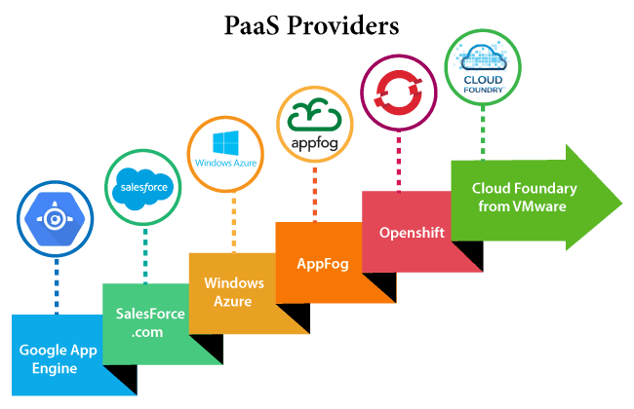

# **Software as a Service | SaaS**

SaaS is also known as "**On-Demand Software**". It is a software distribution model in which services are hosted by a cloud service provider. These services are available to end-users over the internet so, the end-users do not need to install any software on their devices to access these services.

There are the following services provided by SaaS providers -

**Business Services** - SaaS Provider provides various business services to start-up the business. The SaaS business services include **ERP** (Enterprise Resource Planning), **CRM** (Customer Relationship Management), **billing**, and **sales**.

**Document Management** - SaaS document management is a software application offered by a third party (SaaS providers) to create, manage, and track electronic documents.

**Example:** Slack, Samepage, Box, and Zoho Forms.

**Social Networks** - As we all know, social networking sites are used by the general public, so social networking service providers use SaaS for their convenience and handle the general public's information.

**Mail Services** - To handle the unpredictable number of users and load on e-mail services, many e-mail providers offering their services using SaaS.

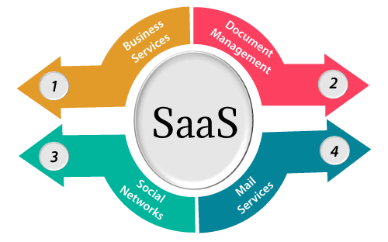

## Advantages of SaaS cloud computing layer

**1) SaaS is easy to buy**

SaaS pricing is based on a monthly fee or annual fee subscription, so it allows organizations to access business functionality at a low cost, which is less than licensed applications.

Unlike traditional software, which is sold as a licensed based with an up-front cost (and often an optional ongoing support fee), SaaS providers are generally pricing the applications using a subscription fee, most commonly a monthly or annually fee.

**2. One to Many**

SaaS services are offered as a one-to-many model means a single instance of the application is shared by multiple users.

**3. Less hardware required for SaaS**

The software is hosted remotely, so organizations do not need to invest in additional hardware.

**4. Low maintenance required for SaaS**

Software as a service removes the need for installation, set-up, and daily maintenance for the organizations. The initial set-up cost for SaaS is typically less than the enterprise software. SaaS vendors are pricing their applications based on some usage parameters, such as a number of users using the application. So SaaS does easy to monitor and automatic updates.

**5. No special software or hardware versions required**

All users will have the same version of the software and typically access it through the web browser. SaaS reduces IT support costs by outsourcing hardware and software maintenance and support to the IaaS provider.

**6. Multidevice support**

SaaS services can be accessed from any device such as desktops, laptops, tablets, phones, and thin clients.

**7. API Integration**

SaaS services easily integrate with other software or services through standard APIs.

**8. No client-side installation**

SaaS services are accessed directly from the service provider using the internet connection, so do not need to require any software installation.

## Disadvantages of SaaS cloud computing layer

**1) Security**

Actually, data is stored in the cloud, so security may be an issue for some users. However, cloud computing is not more secure than in-house deployment.

**2) Latency issue**

Since data and applications are stored in the cloud at a variable distance from the end-user, there is a possibility that there may be greater latency when interacting with the application compared to local deployment. Therefore, the SaaS model is not suitable for applications whose demand response time is in milliseconds.

**3) Total Dependency on Internet**

Without an internet connection, most SaaS applications are not usable.

**4) Switching between SaaS vendors is difficult**

Switching SaaS vendors involves the difficult and slow task of transferring the very large data files over the internet and then converting and importing them into another SaaS also.

## Popular SaaS Providers

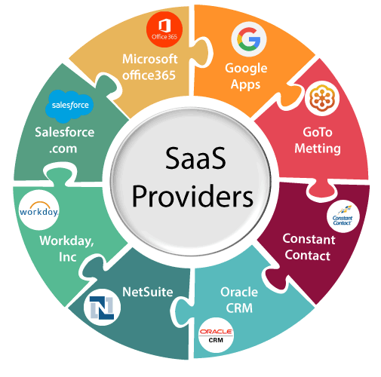

The below table shows some popular SaaS providers and services that are provided by

them –

# **Virtualization in Cloud Computing**

**Virtualization** is the **"creation of a virtual (rather than actual) version of something, such as a server, a desktop, a storage device, an operating system or network resources".**

In other words, Virtualization is a technique, which **allows to share a single physical instance of a resource or an application among multiple customers and organizations.** It does by assigning a logical name to a physical storage and providing a pointer to that physical resource when demanded.

## What is the concept behind the Virtualization?

Creation of a virtual machine over existing operating system and hardware is known as Hardware Virtualization. A Virtual machine provides an environment that is logically separated from the underlying hardware.

The machine on which the virtual machine is going to create is known as **Host Machine** and that virtual machine is referred as a **Guest Machine**

## Types of Virtualization:

1. Hardware Virtualization.
2. Operating system Virtualization.
3. Server Virtualization.
4. Storage Virtualization.

### **1) Hardware Virtualization:**

When the virtual machine software or virtual machine manager *(VMM) is directly installed on the hardware system* is known as hardware virtualization.

The main job of hypervisor is to control and monitoring the processor, memory and other hardware resources.

After virtualization of hardware system we can install different operating system on it and run different applications on those OS.

**Usage:**

Hardware virtualization is mainly done for the server platforms, because controlling virtual machines is much easier than controlling a physical server.

### **2) Operating System Virtualization:**

When the virtual machine software or virtual machine manager *(VMM) is installed on the Host operating system* instead of directly on the hardware system is known as operating system virtualization.

**Usage:**

Operating System Virtualization is mainly used for testing the applications on different platforms of OS.

### **3) Server Virtualization:**

When the virtual machine software or virtual machine manager *(VMM) is directly installed on the Server system* is known as server virtualization.

**Usage:**

Server virtualization is done because a single physical server can be divided into multiple servers on the demand basis and for balancing the load.

### **4) Storage Virtualization:**

Storage virtualization is the *process of grouping the physical storage from multiple network storage devices so that it looks like a single storage device*.

Storage virtualization is also implemented by using software applications.

**Usage:**

Storage virtualization is mainly done for back-up and recovery purposes.

## How does virtualization work in cloud computing?

**Virtualization** plays a very important role in the cloud computing technology, normally in the cloud computing, users share the data present in the clouds like application etc, but actually with the help of virtualization users shares the Infrastructure.

The **main usage of Virtualization Technology** is to provide the applications with the standard versions to their cloud users, suppose if the next version of that application is released, then cloud provider has to provide the latest version to their cloud users and practically it is possible because it is more expensive.

To overcome this problem we use basically virtualization technology, By using virtualization, all severs and the software application which are required by other cloud providers are maintained by the third party people, and the cloud providers has to pay the money on monthly or annual basis.

## virtualization

## What is the AWS Global Cloud Infrastructure?

The AWS Global Cloud infrastructure is the backbone network of global data centers and other platforms that Amazon uses to deliver application workloads and AWS services.

* AWS Regions
* AWS Availability Zones
* AWS Local Zones

### **AWS Regions**

The heart of the AWS Global Cloud. **AWS Regions are physical locations around the world where Amazon clusters data centers for application and service delivery in AWS Availability Zones.**

Each AWS Region may offer **different service quality in terms of latency, solutions portfolio, and cost**, based on its geographic location and distance from customer sites.

### **AWS Availability Zones**

An Availability Zone (AZ) is a **grouping of one or more discrete data centers that provide applications and services in an AWS region.**

Each AZ contains redundant connectivity, power, and networking capabilities, and individual AZs are physically separated (isolated) from each other by a meaningful distance. All AZs in an AWS Region are connected through low latency and high throughput networking channels.

Because of their connectivity and redundancy, AZs provide customer application and database operating environments that are more scalable and fault tolerant. Because regional AZs are physically isolated from each other, applications can be partitioned across multiple AZs for **high availability.**

### **AWS Local Zones**

AWS Region **extensions that place compute, storage, databases, and other AWS services in closer proximity to large populations, IT centers, and industries.**

AWS Local Zones are provisioned **to run high-speed applications**—such as **media, entertainment, real-time gaming, live video streaming, and machine learning**—that require single-digit millisecond latency to service users in specific geographic locations.

AWS COMPUTE

**AWS** provides a variety of cost-effective and flexible **computing services** to meet the needs of your organization such as **Amazon Elastic Compute Cloud (EC2), Amazon Elastic Container Service (ECS), Amazon Elastic Container Service for Kubernetes (EKS), Amazon Lightsail, AWS Batch, and AWS Lambda** to name a few. For some services like Amazon EC2, you have extensive control of the underlying resources while for others, AWS has full control.

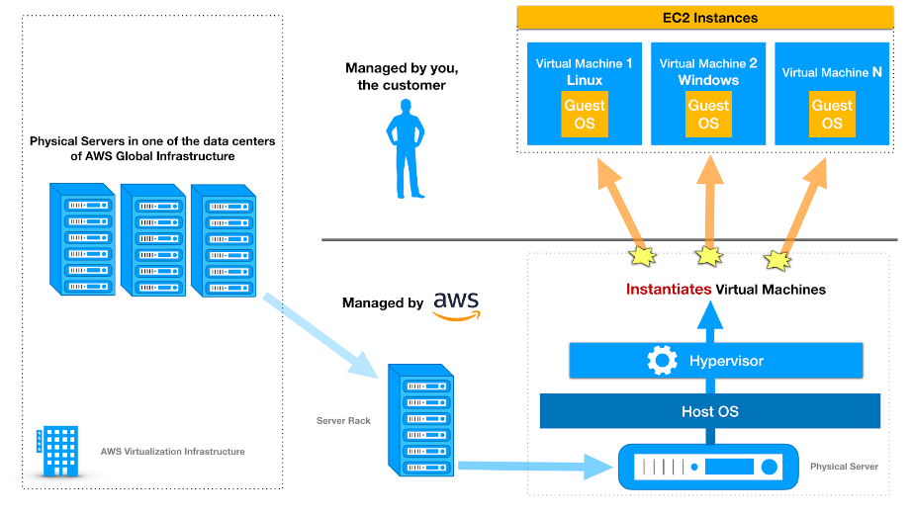

## Networking Services

 The networking services offered by Amazon have been listed below:

* **Amazon VPC:** It helps in provisioning an isolated section of the Amazon Web services Cloud.
* **Amazon Route 53:** It is a reliable and cost-effective method of routing end users to other internet applications.
* **Amazon CloudFront:** It delivers quick and highly secure, programmable content delivery network (CDN).
* **Elastic Load Balancing:** It help in achieving fault tolerance for applications by providing scalability, high-performance and security.

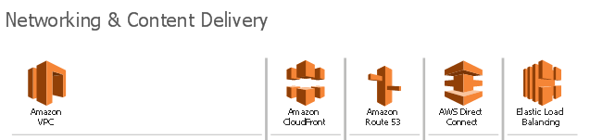

### **Storage Services**

**1. Object Storage** – Applications developed within the cloud often cash in on object storage’s vast scalability and metadata characteristics. Object storage solutions like [**Simple Storage Service (Amazon S3)**](https://k21academy.com/amazon-web-services/aws-solutions-architect/aws-storage-overview-types-benefits/#1_Amazon_Simple_Storage_Service_Amazon_S3) and [**Amazon Glacier**](https://k21academy.com/amazon-web-services/aws-solutions-architect/aws-storage-overview-types-benefits/#2_Amazon%20Glacier)are ideal for building modern applications from scratch that need scale and adaptability, and may even be wont to import existing data stores for analytics, backup, or archive.

**2. File Storage –** Many applications got to access shared files and need a filing system. this sort of storage is usually supported with a Network Attached Storage (NAS) server. File storage solutions like[**Elastic File System (Amazon EFS)**](https://k21academy.com/amazon-web-services/aws-solutions-architect/aws-storage-overview-types-benefits/#3_Elastic_File_System_Amazon_EFS)are ideal to be used in cases like large content repositories, development environments, media stores, or user home directories.

**3. Block Storage –** Other enterprise applications like databases or ERP systems often require dedicated, low latency storage for every host. this is often analogous to direct-attached storage (DAS) or a cargo area Network (SAN). Block-based cloud storage solutions like[**Elastic Block Store (Amazon EBS)**](https://k21academy.com/amazon-web-services/aws-solutions-architect/aws-storage-overview-types-benefits/#4_EBS)and [**EC2 Instance Storage**](https://k21academy.com/amazon-web-services/aws-solutions-architect/aws-storage-overview-types-benefits/#4_EC2_Instance_Storage)

## ****Storage Offered By Amazon Web Services (AWS)****

